Notice of Tutorial II

1. Time & Venue
Two identical sessions are offered. Every student only needs to attend one session.
- Session 1: May 18th, 15:30, Room 6A303
- Session 2: May 19th, 15:30, Room 6A303

2. Task Requirement
Please implement a chess game based on Raylib. You need to provide complete and runnable code that supports the chess gameplay demonstrated in class.
- The MVC architecture is not mandatory. Any valid and runnable Raylib-based chess game is acceptable.
- You may refer to the MVC implementation uploaded in the Feishu document (chess_MVC) for coding reference.
https://lbwcs29n19.feishu.cn/drive/folder/H1QhftTU1lVafedOlVncAFiGnkc
For the complete project you may download the zip file from the link. (VS 2022, if you are using VS 2026, just use the files under src and include)
https://cloud.tsinghua.edu.cn/f/bca21af5ac7941c5a481/
You may add all the files according the following snapshot
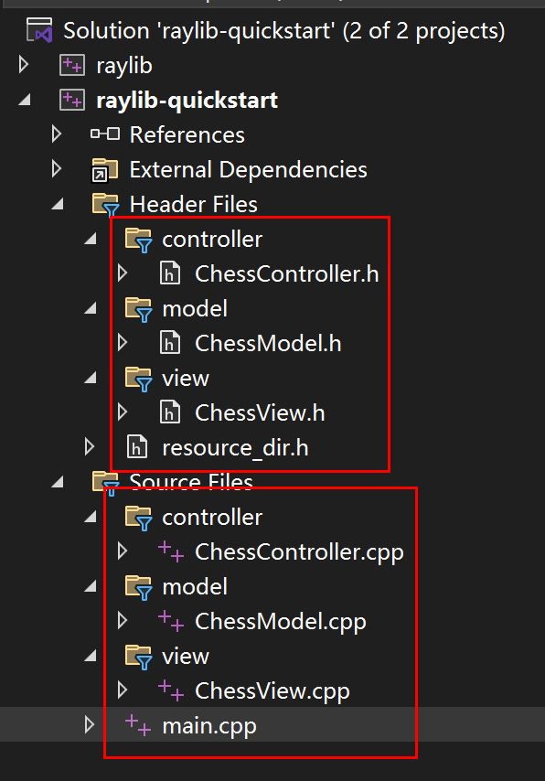

3. On-site Guidance & Scoring Rules
- If you encounter any difficulties installing Raylib or running the program, please consult the on-site teaching assistants for help.
- After you successfully compile and run the chess game, demonstrate your program to one teaching assistant.
- Complete the registration on site to earn 5 points for this tutorial.

4. Teaching Assistants Arrangement
- May 18th: Yuchun Ma, Zhuojun Li, Qixu Xie
- May 19th: Kai Su, Rongze Yang, Hanyi Peng

